Steps to disable monitoring (Alert) from a server and how to Remove the server from the N-Able Portal

1. Disable monitoring (Alert) from a server.
2. Go to N-Able Portal
3. Select client
4. Go to All Devices Select server.

1. Navigate to Overview 🡪 select the Alert that we need to disable.

1. Navigate to service details and choose Monitoring Option and Disable the alert.

1. Remove the server from the N-Able Portal
2. Go to N-Able Portal
3. Select Client
4. Select server needs to remove (checkbox).
5. Click on Delete Option.

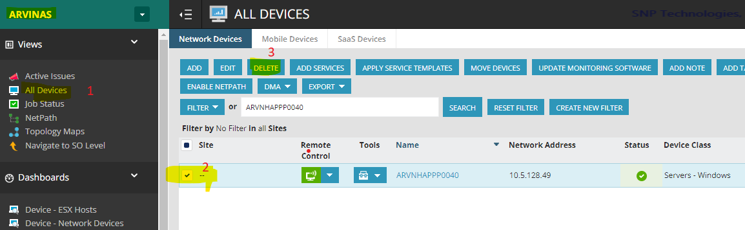

1. Choose the option “**Completely remove device from the system**.”

Check “**Uninstall Local Agent**”

Click on Ok Button.

